Date: 07/04/26
📊 Final Count:
🟢 Bullish | 4
🔴 Bearish | 4
Total | 8

🟢 BULLISH TRADES --- 4
1 | NATIONALUM26AprFUT
2 | KPITTECH26AprFUT
3 | OFSS26AprFUT
4 | SUZLON26AprFUT
🔴 BEARISH TRADES --- 4
1 | PIDILITIND26AprFUT
2 | TORNTPHARM26AprFUT
3 | BIOCON26AprFUT
4 | MANAPPURAM26AprFUT

Trade Taken
🟢 BULLISH SIGNAL --- NATIONALUM26AprFUT

Nifty Bias : 🟢 LONG — Aligned ✅
Crossover : 2026-03-25 12:00 (13 days ago)
Pullback : 2026-04-06 14:45
Low ₹408.5 ≤ EMA9(Low) ₹409.14
High ₹410.35 (breakout level)
Confirm : 2026-04-07 09:15 (+3 candle)
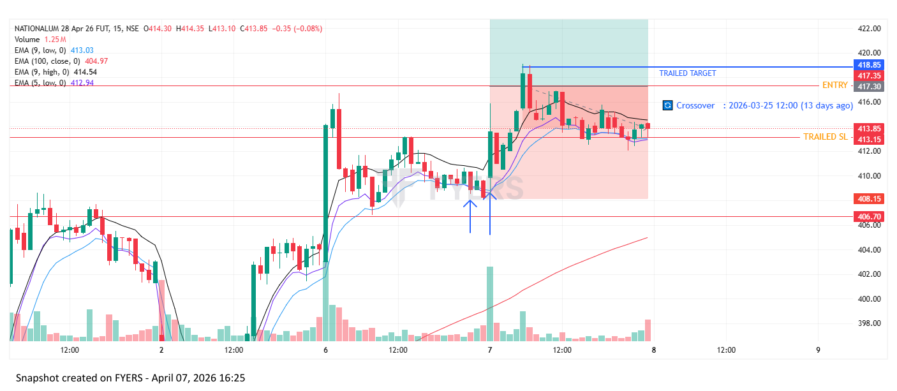

Trade Not Taken
🔴 BEARISH SIGNAL --- PIDILITIND26AprFUT

Nifty Bias : 🟢 LONG — Counter Trend ⚠️
Crossover : 2026-04-01 15:15 (6 days ago)
Pullback : 2026-04-06 14:45
High ₹1297.5 ≥ EMA9(High) ₹1290.24
Low ₹1287.6 (breakdown level)
Confirm : 2026-04-07 09:15 (+3 candle)

🔴 BEARISH SIGNAL --- TORNTPHARM26AprFUT

Nifty Bias : 🟢 LONG — Counter Trend ⚠️
Crossover : 2026-04-01 11:00 (6 days ago)
Pullback : 2026-04-06 14:45
High ₹4025 ≥ EMA9(High) ₹4015.18
Low ₹4009.7 (breakdown level)
Confirm : 2026-04-07 09:15 (+3 candle)
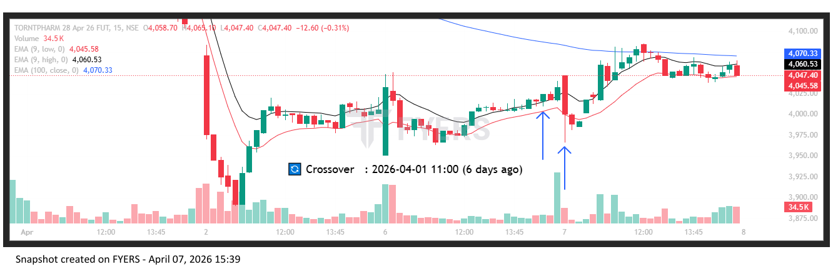
🔴 BEARISH SIGNAL --- BIOCON26AprFUT

Nifty Bias : ⚠️ CHOPPY — Choppy ⚠️
Crossover : 2026-04-01 14:30 (6 days ago)
Pullback : 2026-04-06 15:00
High ₹357.4 ≥ EMA9(High) ₹356.05
Low ₹356.4 (breakdown level)
Confirm : 2026-04-07 09:30 (+3 candle)
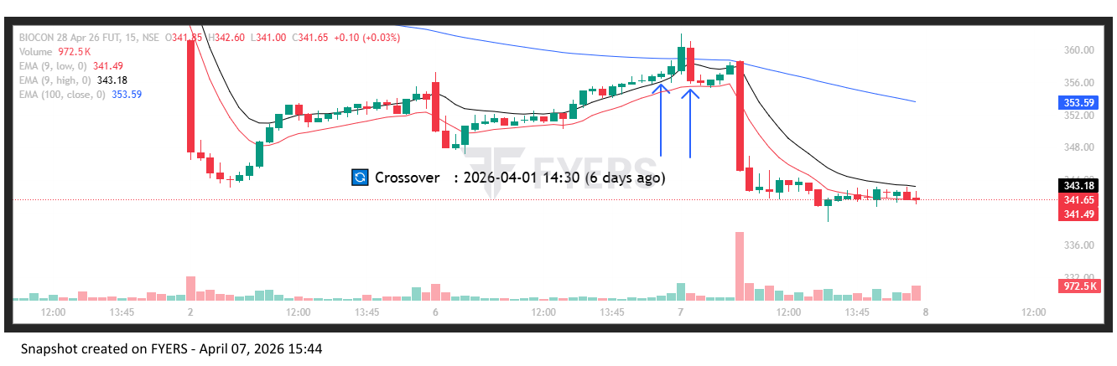
🟢 BULLISH SIGNAL --- KPITTECH26AprFUT

Nifty Bias : ⚠️ CHOPPY — Choppy ⚠️
Crossover : 2026-04-02 10:45 (5 days ago)
Pullback : 2026-04-06 14:45
Low ₹695.5 ≤ EMA9(Low) ₹698.08
High ₹699.8 (breakout level)
Confirm : 2026-04-07 09:15 (+3 candle)
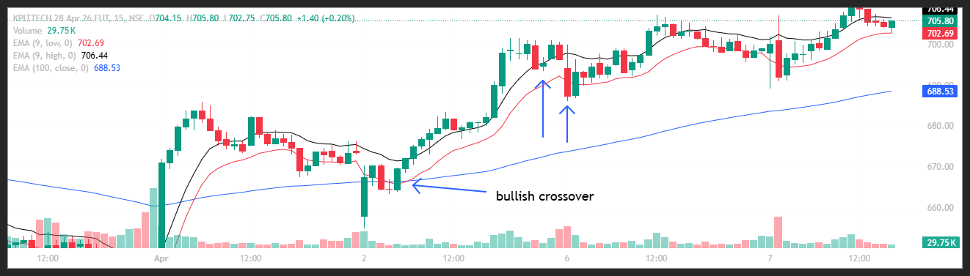
🟢 BULLISH SIGNAL --- OFSS26AprFUT

Nifty Bias : ⚠️ CHOPPY — Choppy ⚠️
Crossover : 2026-04-02 11:00 (5 days ago)
Pullback : 2026-04-06 14:45
Low ₹7001.5 ≤ EMA9(Low) ₹7013.65
High ₹7032.5 (breakout level)
Confirm : 2026-04-07 09:15 (+3 candle)
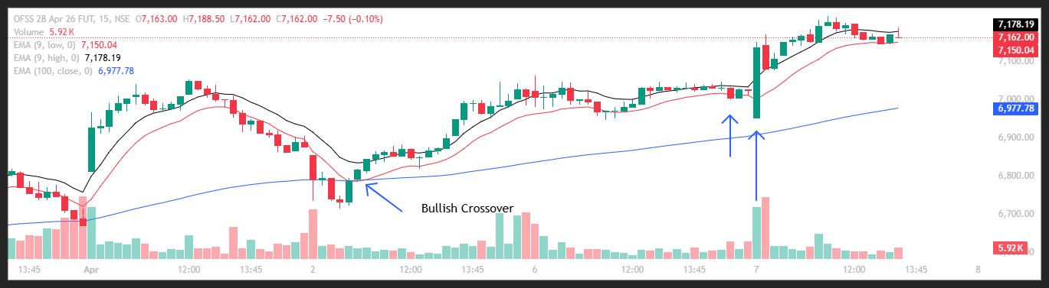
🟢 BULLISH SIGNAL --- SUZLON26AprFUT

Nifty Bias : 🟢 LONG — Aligned ✅
Crossover : 2026-04-06 12:00 (a day ago)
Pullback : 2026-04-07 12:45
Low ₹41.52 ≤ EMA9(Low) ₹41.64
High ₹41.67 (breakout level)
Confirm : 2026-04-07 13:30 (+3 candle)

🔴 BEARISH SIGNAL --- MANAPPURAM26AprFUT

Nifty Bias : 🟢 LONG — Counter Trend ⚠️
Crossover : 2026-04-07 12:30 (3 hours ago)
Pullback : 2026-04-07 14:45
High ₹257.6 ≥ EMA9(High) ₹257.01
Low ₹256.95 (breakdown level)
Confirm : 2026-04-07 15:15 (+2 candle)

📊 TRADING SUMMARY
━━ ALL TRADES (07-Apr) ━━━━━━━━━━━━━━━━━━━━
Total Signals | 8
Taken Trades | 08
Not Taken | 00
Balance | Rs. 1,09,75,128.40
Current Balance | Rs. 1,09,38,519.76

━━ TODAY'S LIVE TRADING (07-Apr) ━━━━━━━━━━━━━━━━━━━━
Total | 8
Completed | 08
Wins ✅ | 5
Losses ❌ | 3
Open ⏳ | 0
Win Rate | 62.5%
Net P/L | -Rs. 10,532.96 , +0.00 pts
Brokerage | Rs. 320.00
Taxes & Fees | Rs. 1520.46

━━ ALL-TIME LIVE TRADING ━━━━━━━━━━━━━━━━━━━━
Completed | 59
Wins ✅ | 32
Losses ❌ | 27
Open ⏳ | 4
Win Rate | 54.2%
Net P/L | -Rs. 47,141.62 , -74,347.50 pts
Brokerage | Rs. 2360.00
Taxes & Fees | Rs. 9151.97

━━ TODAY'S BACKTEST (07-Apr) ━━━━━━━━━━━━━━━━━━━━
Signals Today | 8
Resolved | 6
TARGET HIT ✅ | 3
SL HIT ❌ | 3
Open ⏳ | 2
Win Rate | 50.0%
Total PnL | -38.85 pts

━━ ALL-TIME BACKTEST SUMMARY ━━━━━━━━━━━━━━━━━━━━
Total Signals | 22
TARGET HIT ✅ | 4
SL HIT ❌ | 16
Open ⏳ | 2
Win Rate | 20.0%
Total PnL | -378.55 pts

🤖 TRADE BEHAVIOUR ANALYSIS
✅ Trades Taken — What signals fired:
1. NATIONALUM26AprFUT — Bullish crossover, aligned with Nifty bias. Entry ₹413.6, SL ₹408.5.
⛔ Trades Not Taken (7 signals skipped):
Counter-trend to Nifty bias — skipped (3): PIDILITIND26AprFUT, TORNTPHARM26AprFUT, MANAPPURAM26AprFUT
Nifty choppy — skipped (3): BIOCON26AprFUT, KPITTECH26AprFUT, OFSS26AprFUT
Aligned but not entered (1): SUZLON26AprFUT
📝 88% of today's signals were not acted on. 3 were counter-trend — correct discipline to avoid. 3 fired during choppy Nifty conditions — high noise, wise to skip. 1 aligned signals were not taken — review if entry was missed or risk was too high.

